INTERNET OF THINGS

SMART IOT GARBAGE MONITORING SYSTEM

**PROJECT REPORT**

09/11/2017

**Contibuter:-**

**Suyash Banzal**

**Table of Contents**

Abstract

Introduction

Hardware and software requirements

Database connection establishment

Firebase Android connectivity

Block diagram

Use Case

Pin diagram of RSP3

Journal related studies

Technical details

Features

Advantages

Scope

Conclusion

Implementation

Screenshots

References

**ABSTRACT**

One of the main concerns with our environment has been solid waste managementwhich effects the health and environment of our society. The detection, monitoring and the management of wastes is one of the main problems of the present era. The old-style of manually monitoring the waste in waste bins is a heavy processwhich utilizes too much human effort, time and cost which can be easily avoided with our present technologies. This is our solution, a method by which waste management is automated.

**INTRODUCTION**

IoT Garbage Monitoring system is an advanced way which will help in keeping the cities clean and healthy. The system monitors the garbage bins and informs about the level of garbage collected in the garbage bins through garbage monitoring mobile app. For this, the system uses ultrasonic sensors with each placed at the top of the bins to detect garbage level and compare it with the garbage bins depth. The system uses Raspberry pi 3, LCD screen, WIFI modem for sending data along with a firebase system to store collected runtime data. This system is powered by 12V batteries. The LCD screen is required to display status of the level of garbage that is collected in the bins. While the mobile application is built to show status to the user monitoring it. The mobile application gives a graphical view of the garbage bins and highlights the garbage collected in color so as to show the level of garbage collected. The LCD screen show the status of the garbage level. The system puts on a buzzer when the level of garbage collected crosses the specified limit. So, the system will help to keep the city clean by providing acknowledgement about the garbage levels of the bins by providing graphical image of bins.

**HARDWARE & SOFTWARE REQUIREMENT**

* **Raspberry pi 3:** Its an open hardware system, with the exception of a primary chip on the Raspberry Pi, the Broadcom SoC (System on a Chip), which runs most of the main components of board–CPU, graphics, memory as well as the USB controller. It is used in our project to communicate to the ultrasonic sensors placed in the dustbins all around the area and fetch data which is sensed by them. It also simplifies the task of connecting to Internet using prebuilt libraries that can be downloaded.
* **Power Supply:** We are using a 12v power supply in our project. Its mainly used to provide DC voltage to components on board. 3.3V for lpc2138 and 4.2v for Wi-Fi module is applied from power supply. 5V is required for relay applied from the power supply.
* **WI-FI Modem:** It has a powerful on-board processing and storage capacity that allows it to be integrated with sensors and other application-specific devices through the GPIOs with minimum development up-front and minimum loading during runtime. Its high degree of on-chip integration allows minimal external circuitry, including the front-end module and is designed to occupy minimal PCB area.
* **Ultrasonic Sensor:** The Ultrasonic Sensor sends out a high-frequency sound pulse and then times how long it takes for the echo of the sound to reflect back. The sensor has 2 openings on its front. One opening transmits ultrasonic waves, (like a tiny speaker), the other receives them, (like a tiny microphone). The speed of sound is approximately 341 meters (1100 feet) per second in air. The ultrasonic sensor uses this information along with the time difference between sending and receiving the sound pulse to determine the distance to an object.
* **GSM Module:** It is used to send message to the garbage depot if the Garbage Can exceeds the set threshold level. With the help of GSM module interfaced, we can send short text messages to the required municipal office. GSM module is provided by the sim, it uses the mobile service provider and sends SMS to respective authorities as pre programmed. It operates at either the 900 MHz or 1800 MHz frequency-band.
* **RFID tags:** RFID tags will help municipalities and waste removal service organizations optimize data collection speed and integrity, enabling pay-as-you-throw and recycling incentive programs. RFID waste management solutions support identification and traceability of waste streams. The status of each dustbin can be tracked and observed individually.

**Database connectivity establishment**

We are using Google’s freely available Firebase to manage the real-time database of our Smart Garbage Monitoring System.

**Firebase** is a technology that allows us to make web applications with no server-side programming so that development turns out to be quicker and easier. With Firebase there is not need to stress on provisioning servers or in building REST APIs because it is possible with just a little bit of configuration. We can give Firebase a chance to take every necessary step like - storing data, verifying users along with implementing access rules.

It also supports web, iOS, OS X, and Android clients. Applications that uses Firebase system can just use and control data, without any need to think about how data will be stored or synchronized across various examples of application in real time. Also there is no need to write server-side code or to arrange a complex server framework to get an app started with Firebase.

**FIREBASE ANDROID CONNECTIVITY**

* The firebase is configured to android app through SHA
* It reads the data set that includes all arguments stored in firebase and outputs the readings.

**BLOCK DIAGRAM**

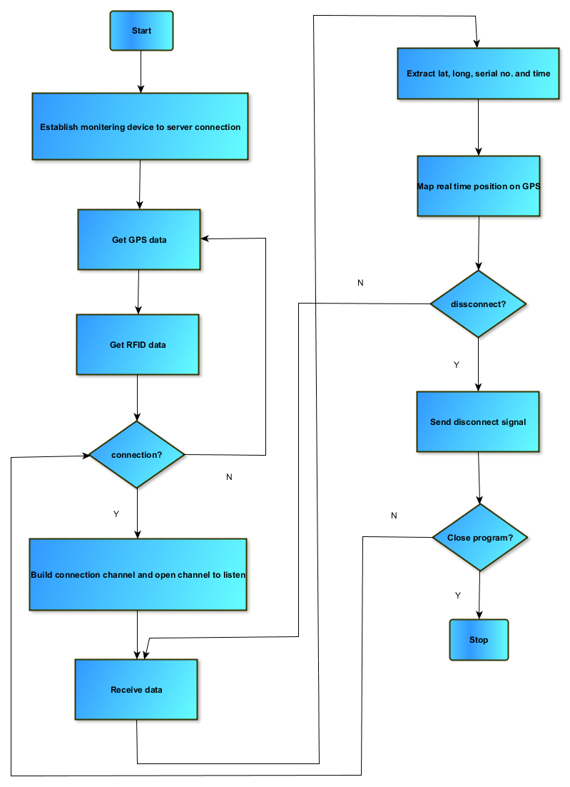

**USE CASE**

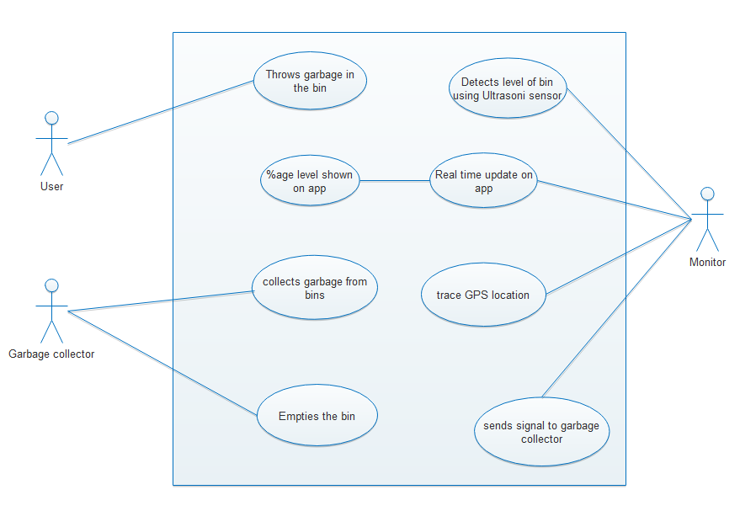

**PIN DIAGRAM OF RASPBERRY PI-3**

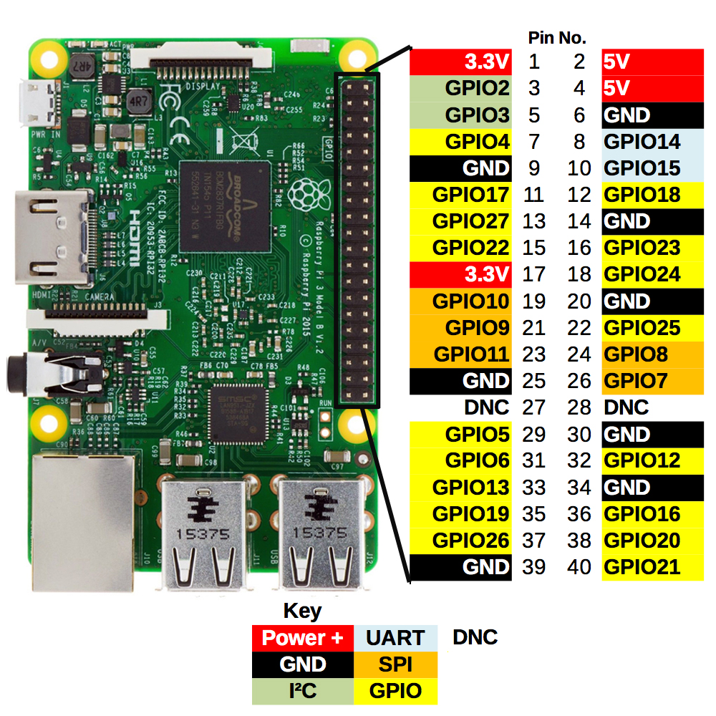

**JOURNAL RELATED STUDIES**

**International Journal of Innovative Research in Electrical, Electronics, Instrumentation and Control Engineering**

The journal proposed implementation of Smart Garbage Management and Monitering System using sensors, microcontrollers along with GSM module that guarantees the cleaning of dustbins soon once the garbage level reaches the maximum. If dustbin is not cleaned in certain time, then the record is sent to the higher authority who can take suitable action against the concerned contractor. The system helps in monitoring false report and hereafter can reduce the corruption in overall management system. This **reduces the total number of tours of garbage collection vehicle** and thus the overall expenditure associated with garbage collection. So, **it ultimately helps to mantain cleanness in the society**.

Smart collection bin works with the sensors that will view us various levels of garbage in dustbins and also weight sensors get activated to send the output ahead when the threshold level is crossed. If the dustbins are not cleaned on time then the details will be forwarded to higher authorities. To interface this sensor system with GSM system, **Raspberry pi microcontroller is used.** **Level detector consist of IR sensor** which is used to detect level of the garbage in dustbins. Output of level detectors is given to microcontroller. **Four IR sensors are used to specify the different levels of amount of garbage collected in dustbins** which are placed in public area. When the dustbin is filled up to its highest level then the output of fourth IR receiver becomes low. This **output is forwarded to microcontroller** to send the message to Control room through GSM module. At receiver part, control room is present where all the activities will be managed. This system guarantees cleaning of dustbins when garbage level reaches the maximum. Thus, the “Smart Garbage Management System” makes the garbage collection very efficient.

**International Journal of Science and Research (IJSR)**

The journal presents techniques that can be implemented to check for the overflow of dustbins and inform the specified authorities. Firstly, the **IR sensors act as level detector**. The sensor senses the contents of the dustbin and sends the signals or data to Dashboard section and then this section will **send a mail or a message** to the respective Municipal or Government authority person or collection vehicle. If the dustbin is still not cleaned in precise time then the record will be sent to the higher authorities who can take appropriate action against the concerned contractor.

Secondly, we can make use of **ultrasonic sensors**, once the garbage reaches a threshold level then ultrasonic sensor will trigger GSM modem which will keep on alerting the required authority until garbage in dustbin is cleaned. Once the dustbin is cleaned then people can reuse dustbin. The ultrasonic sensor is used **to fetch height of the garbage** filledat various intervals of time. We can make use of three sensors at heights like h/3, 2h/3 and h, where h is height of bin but in order to make it affordable and achieve relevant results, only **one sensor** can also be placed at the surface level.

Numerous dustbins can be located all over the city or Campus and these dustbins are provided with low cost embedded device which helps in tracing the level of the garbage bins and also a **unique ID** will be provided for every dustbin in city so that its easy to recognize which garbage bin is full. Also, we can use the previously stated IR sensors. This method consists of IR transmitter as well as IR receiver. The GUI gives output of what level of garbage is filled. When level in a bin reaches the threshold value then **LED placed at the location of bin starts blinking**. When the blinking LED is clicked, a display will open which will show the location of the bin, status of bin, data and time when the bin got filled, mobile number and text to send to concerned person. The level of waste material in garbage bin will be detected with the help of ultrasonic sensor.

**The Scientific World Journal**

This paper proposes an IoT-based smart garbage system (SGS) composed of number of smart garbage bins (SGBs), routers as well as servers. Each SGB plays a part in collecting food waste, is battery operated for mobility and, consider convenience to resident and also performs various techniques through wireless communication. The server gathers, analyze status of SGBs along with resident information collected by the RFID readers. For server load distribution router is used. This proposed system was operated as pilot project in Gangnam district, a local district in Seoul, the capital of Republic Korea, under the food waste reduction policy of the Korean government. By this proposed system, not only food waste was reduced but also the residents and the government saves some cost.

**TECHNICAL DETAILS**

* Ultrasonic sensor is placed on the inner side of the lid, the one facing the solid waste. As garbage increases, distance between ultrasonic and the waste decreases. This live data will be sent to our micro-controller.
* The micro- controller, the **Raspberry pi** then processe the data and with the help of WIFI sends it to an app.
* What the app do is it visually represents the amount of garbage in the bin with small animation.

So the process will indicate all the bins which require attention, thus leading the user to take the most efficient route.

**FEATURES**

* The smart, sensor based trashbin will detect the level of waste in it and will send the message directly to municipal corporation.
* It can sense all types of waste material no matter it is in the form of solid or liquid.
* According to the filled level of dustbin, vehicles from municipal corporation will choose the shortest path with the help of the “TRANSPORTATION SOFTWARE” which will save a measurable time.
* It highlights “DIGITAL INDIA”.
* The system is simple, if there is any problem with any equipment in future, that part is easily replaceable with the new one without any difficulty or delay.

**ADVANTAGES**

* Less time and fuel consumption as the trucks go only to the filled containers.
* Decreased noise, traffic flow and air pollution as a result of less trucks on the roads.
* Our smart operating system enables two-way communication between the dustbin deployed in the city and service operator. Therefore, the focus is only on collection of route based fill level of the containers. The sensors installed in the containers provide real time information on the fill level. This information helps determine when and where to prioritize collection.
* In this way both service providers and citizens benefit from an optimized system which results in major cost savings and less urban pollution.
* Reduces the infrastructure (trucks, containers), operating (fuel) and maintenance costs of the service by up to 30%.
* Applying this technology to the city optimizes management, resources and costs, and makes it a “SMART CITY”.
* Historical information on collections helps adapt the deployment of containers to the actual needs of the city, therefore reducing the number of containers that mess up the road and increasing public parking spaces.
* It keeps the surroundings clean and green, free from bad odor of wastes, emphasizes on healthy environment and keep cities more beautiful.
* Reducing manpower required to handle the garbage collection.

**SCOPE**

The scope of our project is not restricted to any particular geographic area as long as it has the required IoT infrastructure. This work of ours can be implemented in any city which is big enough to have problems regarding to waste management. A more advanced system can be implemented with the time stamp in which the real clock is used to display to the person at what time the dustbin is full and when the truck driver has collected the waste from the dustbin. This system also has a scope for citizen participation, wherein any grievances from citizens related to waste management is heard. The system can be implemented.

**CONCLUSION**

In this project, an integrated system IoT, GSM, Ultrasonic Sensor is introduced for efficient and economic garbage collection. The developed system provides improved database for garbage collection time and waste amount at each location. We analyzed the solutions currently available for the implementation of IoT. By integrating this project, we can avoid overflow of garbage from containers that are placed in residential area which all were previously either loaded manually or with some help of loaders in traditional trucks. It can monitor the garbage level automatically and send the information to the collection truck. All technologies which are used in this proposed system are good enough to guarantee the practical and perfect for solid garbage collection process monitoring and management for a green environment.

**IMPLEMENTATION**

**Python Code:**

import RPi.GPIO as GPIO #Import GPIO library

import time

import requests

import json

import serial

# Firebase Configuration

firebase_url = 'https://garbage-iot.firebaseio.com/'

GPIO.setmode(GPIO.BCM) #Set GPIO pin numbering

TRIG = 23 #Associate pin 23 to TRIG

ECHO = 24 #Associate pin 24 to ECHO

print("Distance measurement in progress")

GPIO.setup(TRIG,GPIO.OUT) #Set pin as GPIO out

GPIO.setup(ECHO,GPIO.IN) #Set pin as GPIO in

time_hhmmss = time.strftime('%H:%M:%S')

date_mmddyyyy = time.strftime('%d/%m/%Y')

location = 'VIT';

while True:

GPIO.output(TRIG, False) #Set TRIG as LOW

print("Waitng For Sensor To Settle")

time.sleep(2) #Delay of 2 seconds

GPIO.output(TRIG, True) #Set TRIG as HIGH

time.sleep(0.00001) #Delay of 0.00001 seconds

GPIO.output(TRIG, False) #Set TRIG as LOW

while GPIO.input(ECHO)==0: #Check whether the ECHO is LOW

pulse_start = time.time() #Saves the last known time of LOW pulse

while GPIO.input(ECHO)==1: #Check whether the ECHO is HIGH

pulse_end = time.time() #Saves the last known time of HIGH pulse

pulse_duration = pulse_end - pulse_start #Get pulse duration to a variable

distance = pulse_duration * 17150 #Multiply pulse duration by 17150 to get distance

distance = round(distance, 2) #Round to two decimal points

if distance > 2 and distance < 400: #Check whether the distance is within range

print("Distance:",distance - 0.5,"cm")#Print distance with 0.5 cm calibration

#adding data to firebase

data = {'date' : date_mmddyyyy, 'time' : time_hhmmss, 'Distance' : distance}

result = requests.post(firebase_url + '/' + location + '/location.json',data = json.dumps(data))

else:

print("Out Of Range") #display out of range

**SCREENSHOTS**

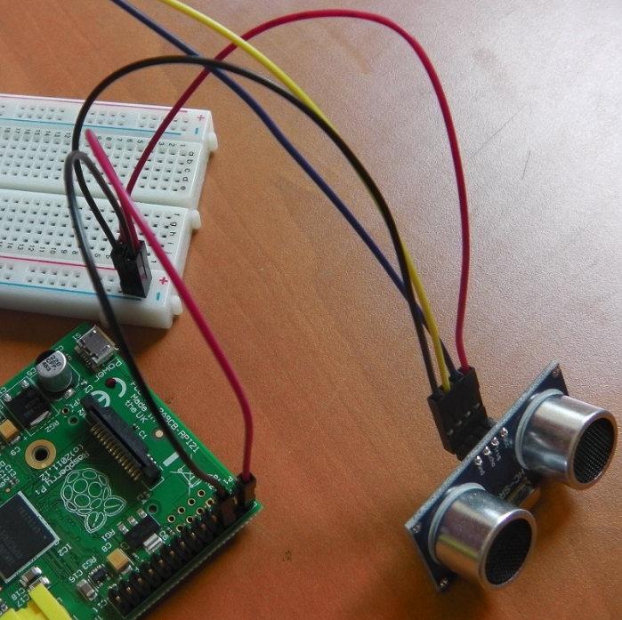

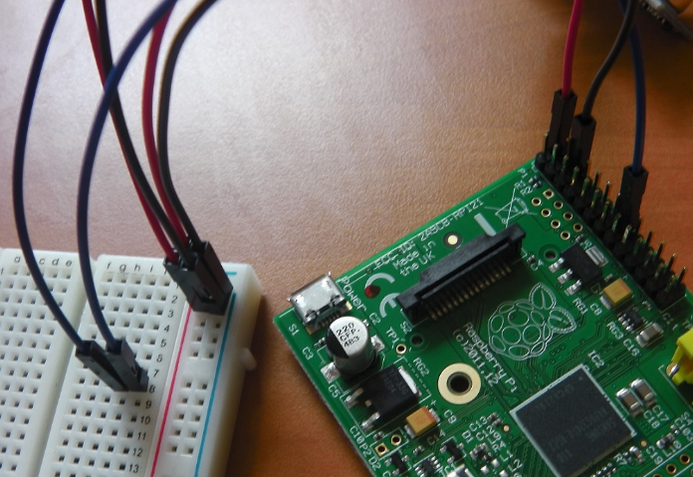

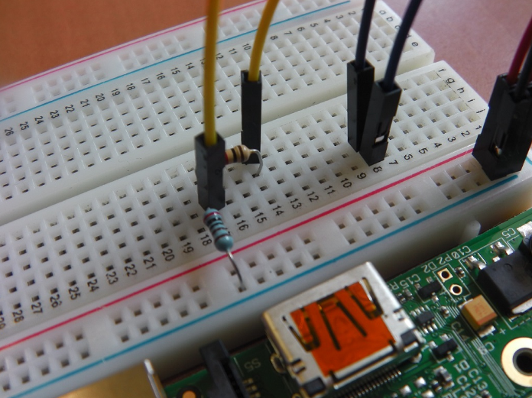

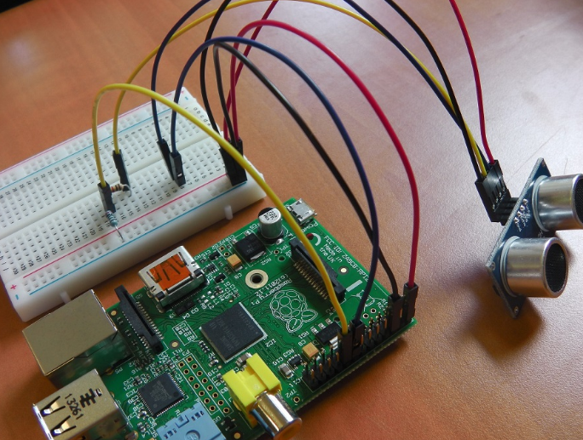

**FIREBASE**

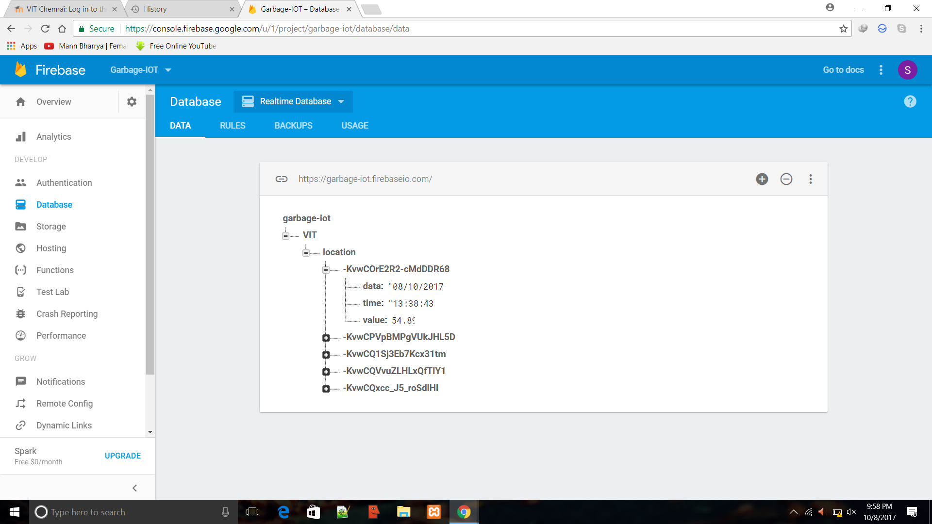

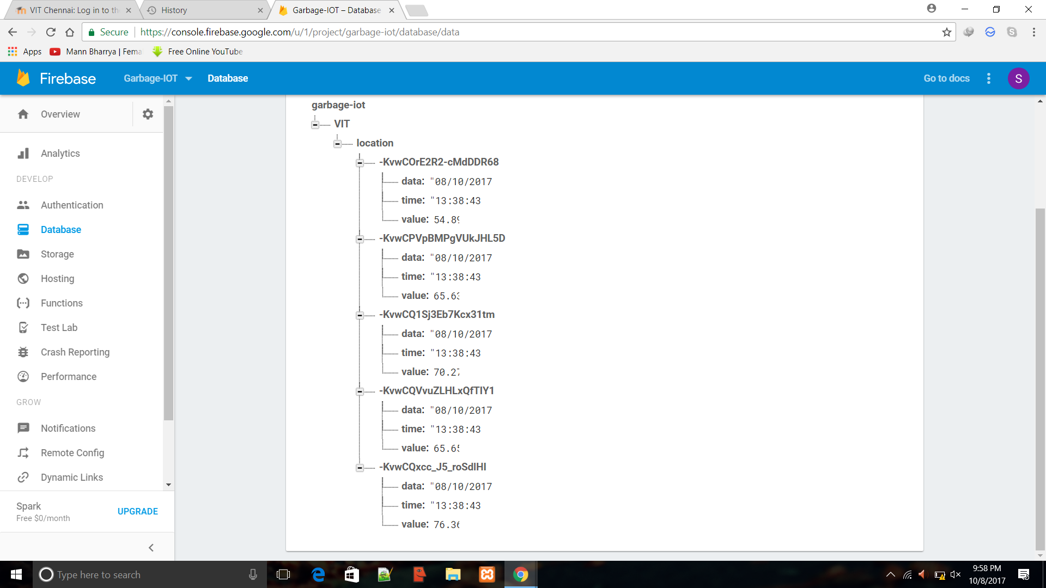

**FIREBASE ANDROID CONNECTIVITY**

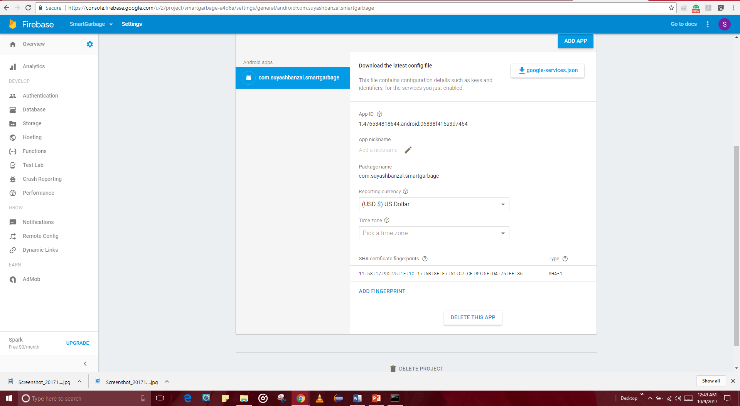

**USER INTERFACE- MOBILE APPLICATION**

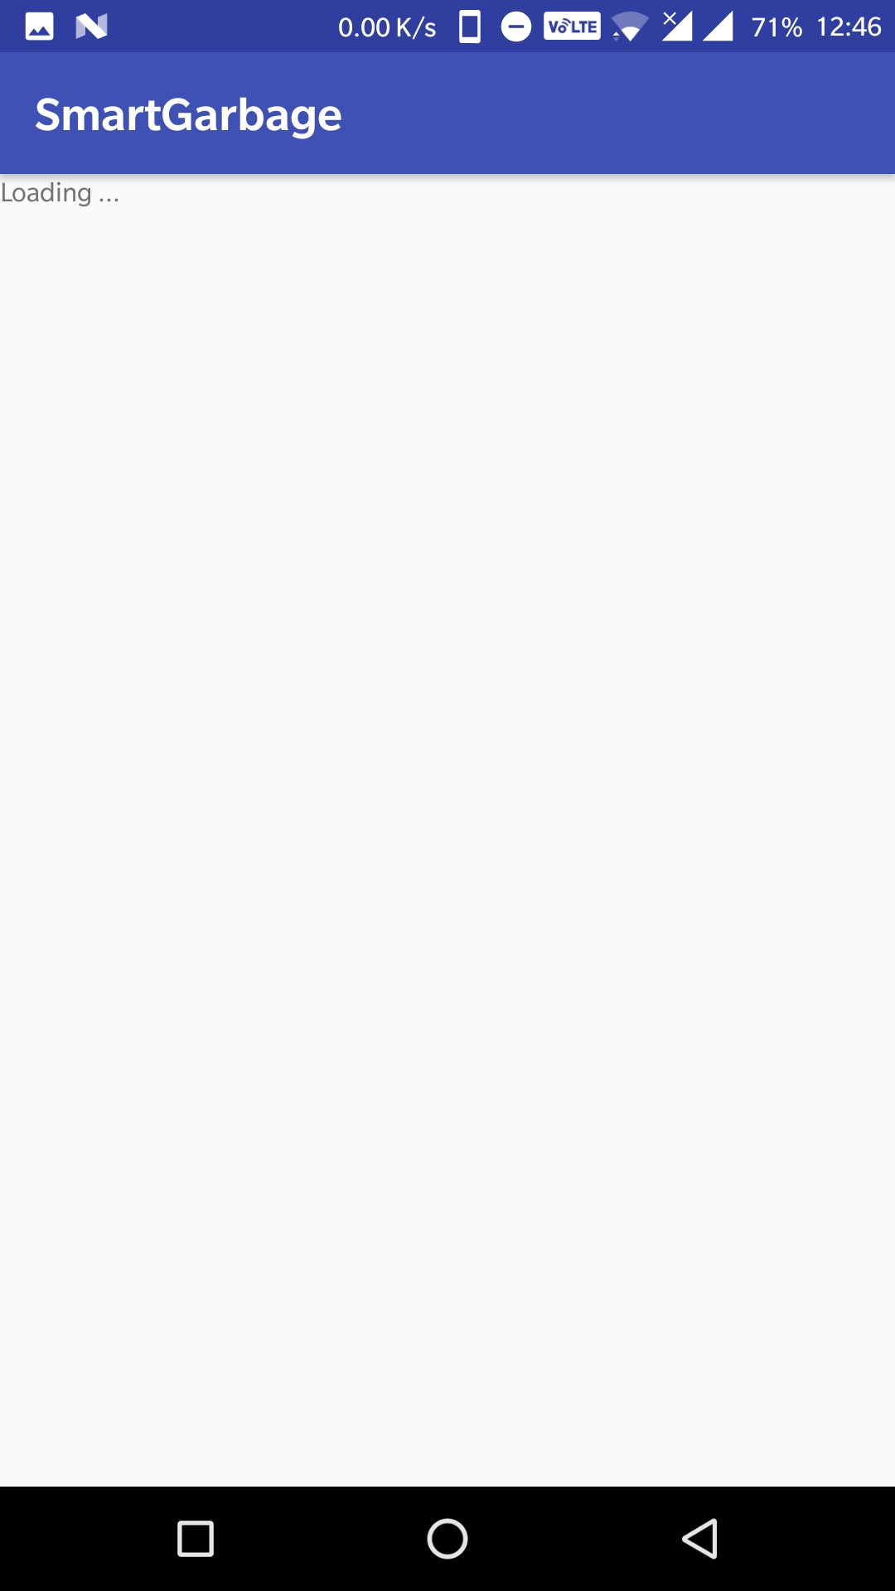 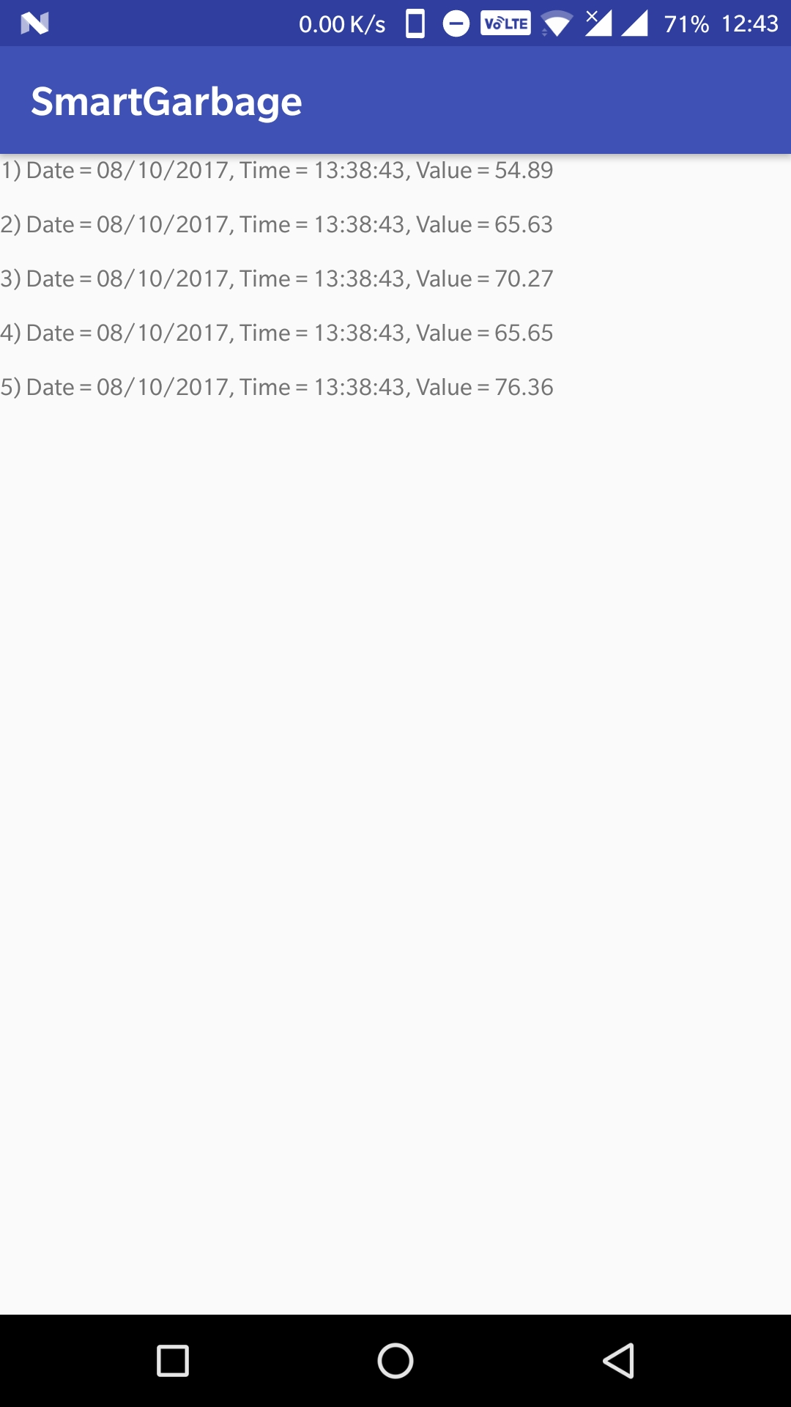

**Optimized User-interface with set Levels**

* **Red**- Grabage needs to be dumped immediately.
* **Yellow**- Mid Grabage level.
* **Green**- Enough space to accommodate more Grabage in the bin.

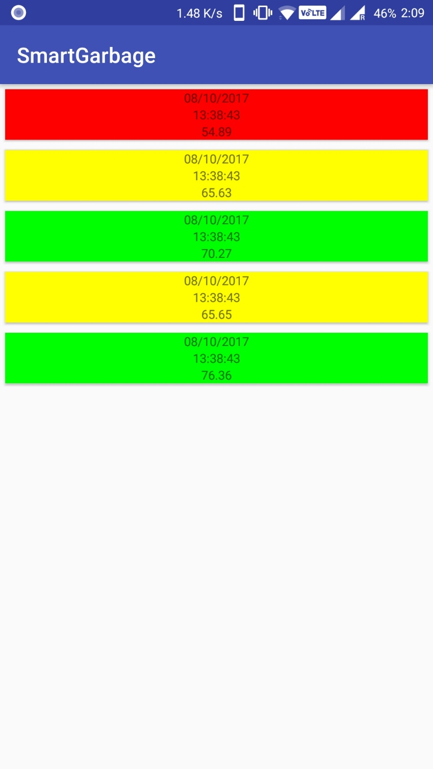

**REFERENCES**

* <https://www.hindawi.com/journals/tswj/2014/646953/>
* <https://www.us-ignite.org/apps/fS2k3yUuyxaAZSYjgcEn4Y/>
* <https://www.ijecs.in/issue/v5-i11/4%20ijecs.pdf>
* <https://www.ijsr.net/archive/v6i3/16021702.pdf>
* <http://ijarece.org/wp-content/uploads/2016/06/IJARECE-VOL-5-ISSUE-5-1576-1578.pdf>
* <http://www.instructables.com/id/Smart-Garbage-Monitoring-System-Using-Internet-of-/>
* <https://www.hindawi.com/journals/tswj/2014/646953/>
* <https://diyhacking.com/connect-raspberry-pi-to-laptop-display/>
* <https://www.dilan.me/articles/tech-notes/getting-started-android-things-raspberrypi-firebase/>
* <https://www.modmypi.com/blog/hc-sr04-ultrasonic-range-sensor-on-the-raspberry-pi/>
* <https://www.modmypi.com/blog/hc-sr04-ultrasonic-range-sensor-on-the-raspberry-pi/>